**Name:** Muhammad Rizwan Khalid

**Class:** BSCS-6A

**Reg.No:** 180459

**Task : 01: Enter Your PIN: -**

/*Name : Muhammad Rizwan Khalid

class: BSCS-6A

Reg.No: 180459*/

#include <stdio.h>

#include <stdlib.h>

int main()

{

int pin = 1234, entry;

printf("WELCOME TO THE SEECS BANK.\n");

printf("ENTER YOUR PIN: ");

scanf_s("%d", &entry);

while (entry != pin)

{

printf("\nINCORRECT PIN. TRY AGAIN.\n");

printf("ENTER YOUR PIN: ");

}

printf("\nPIN ACCEPTED. YOU NOW HAVE ACCESS TO YOUR ACCOUNT.\n");

system("pause");

return EXIT_SUCCESS;

}

/*Question: How is while loop similar to an if statement?

Answer: While loop check the condition given to and if the condition is true then

it executes instructions enclosed in it else if the condition is false then it simple \

neglect the instructions.

Question: How is the while loop different to an if statement?

Answer: While continues to perform the set of instructions inside its body as long as

the condition is true and continues to do so untill the condition become false.

Question: Delete the scanf statement from inside the while loop. What happens? Why?

Answer: If we remove the scanf statement inside the while loop then if we enter the false

pin then loop will continue to perform instructions inside the loop and will not stop at

any point. It is because we have deleted the instruction to make it stop and check the

condition.*/

**Output: -**

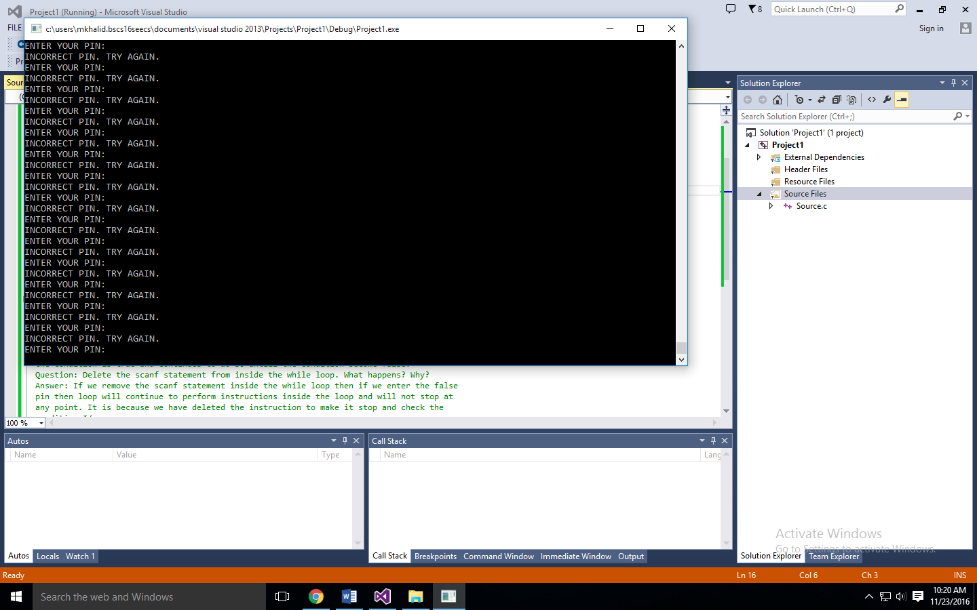

**Task: 02: A Number Guessing Game :-**

/*Name : Muhammad Rizwan Khalid

class: BSCS-6A

Reg.No: 180459*/

#include <stdio.h>

#include <stdlib.h>

int main()

{

int a;

printf("I have chosen a number between 1 and 10. Try to guess it out.\n");

printf("Your Guess : ");

scanf_s("%d", &a);

while (a != 6)

{

printf("This is incorrect. Guess again.\n");

printf("Your Guess : ");

scanf_s("%d", &a);

}

printf("That's right! You Guessed it.\n");

system("pause");

return EXIT_SUCCESS;

}

**Output:**

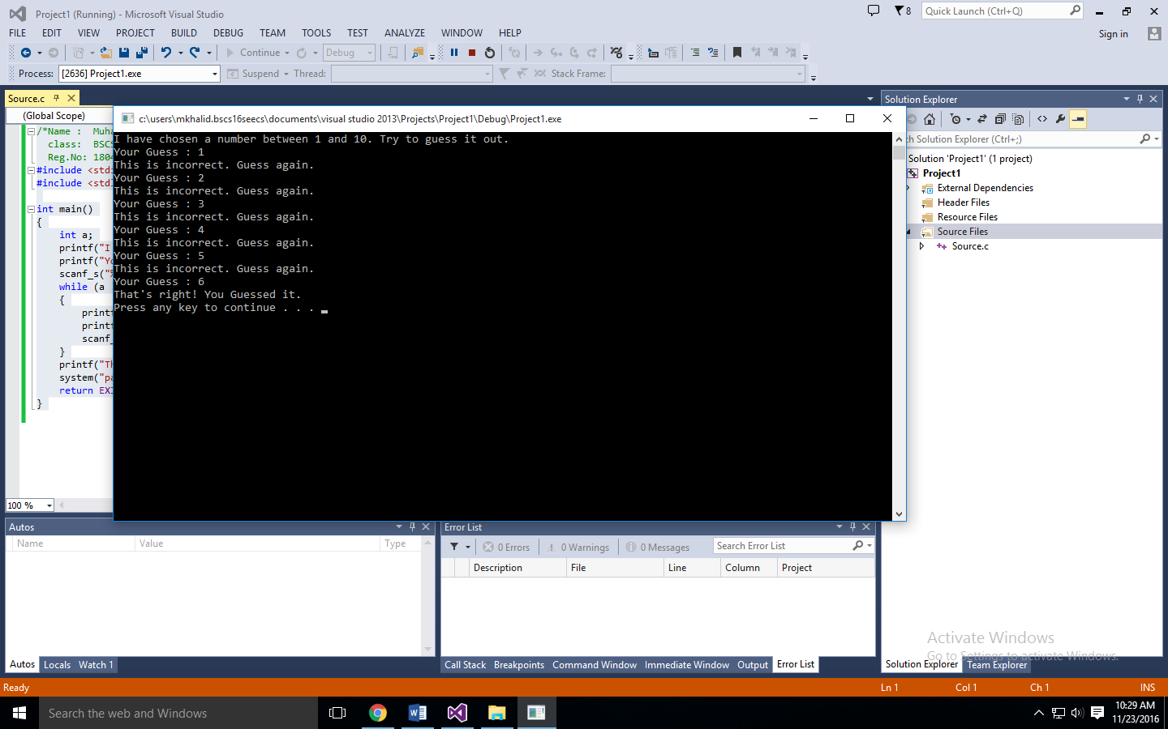

**Task: 03: Dice Doubles: -**

/*Name : Muhammad Rizwan Khalid

Class : BSCS-6A

Reg.No: 180459*/

#include <stdio.h>

#include <stdlib.h>

#include <time.h>

int main()

{

int a, b, c;

srand(time(NULL));

a = rand() % 6 + 1;

b = rand() % 6 + 1;

printf("HERE COMES THE DICE!\n\n");

printf("Roll #1: %d\n", a);

printf("Roll #2: %d\n", b);

c = a + b;

printf("The total is %d!\n", c);

while (a != b)

{

a = rand() % 6 + 1;

b = rand() % 6 + 1;\

c = a + b;

printf("Roll #1: %d\n", a);

printf("Roll #2: %d\n", b);

printf("The total is %d!\n", c);

if (a == b)

break;

}

system("pause");

return 0;

}

**Outout:**

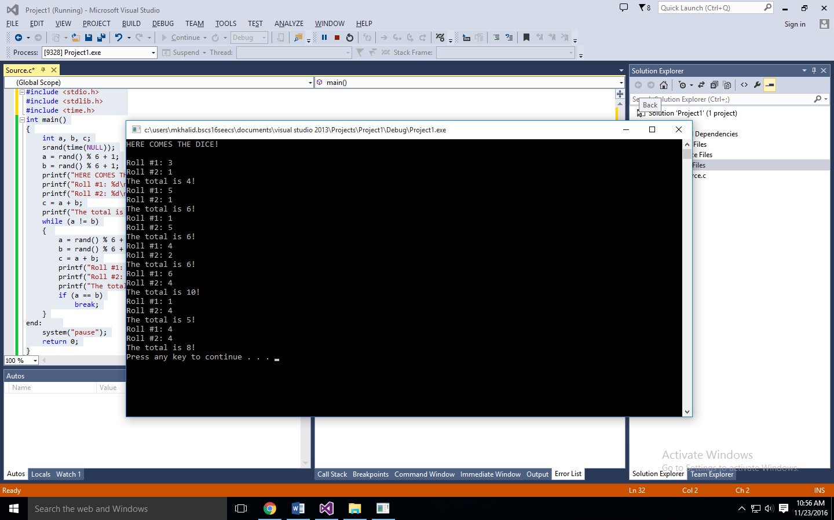

**Task: 04: Counting with a while loop: -**

/*Name : Muhammad Rizwan Khalid

Class : BSCS-6A

Reg.No: 180459*/

#define _CRT_SECURE_NO_WARNINGS

#include <stdio.h>

#include <stdlib.h>

int main()

{

char message[80];

int a;

printf("Type in a message, and I'll display it several times.\n");

printf("Message: ");

gets(message);

printf("How many times? ");

scanf("%d", &a);

int n = 1;

while (n <= a)

{

printf("%d. %s\n", n*10 , message);

n++;

}

system("pause");

return EXIT_SUCCESS;

}

**Output: -**

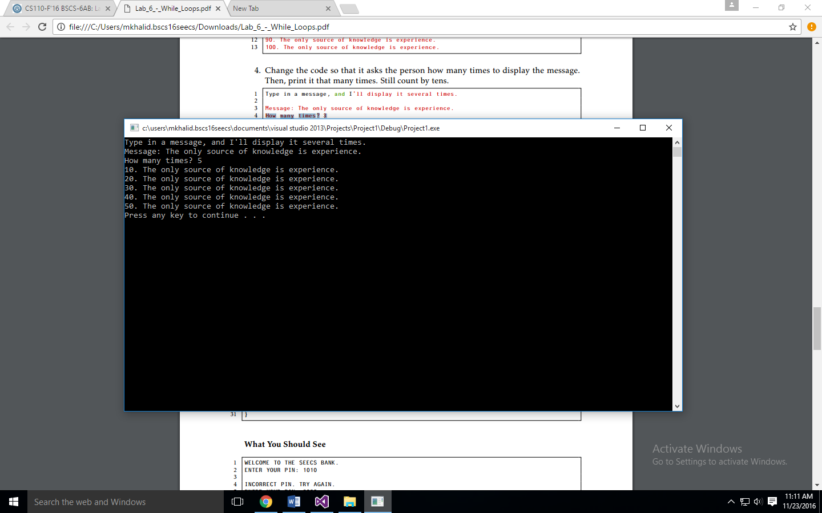

**Task: 05: PIN Lockout: -**

/*Name : Muhammad Rizwan Khalid

Class : BSCS-6A

Reg.No: 180459*/

#define _CRT_SECURE_NO_WARNINGS

#include <stdio.h>

#include <stdlib.h>

int main()

{

int pin = 1234;

int tries = 0;

int maximum_value = 4;

int entry = 0;

printf("WELCOME TO THE SEECS BANK.\n");

printf("\nENTER YOUR PIN: ");

scanf(" %d", &entry);

tries++;

while (entry != pin && tries < maximum_value)

{

printf("\nINCORRECT PIN. TRY AGAIN.\n");

printf("ENTER YOUR PIN: ");

scanf(" %d", &entry);

tries++;

}

if (entry == pin)

printf("\nPIN ACCEPTED. YOU NOW HAVE ACCESS TO YOUR ACCOUNT.\n");

else if (tries >= maximum_value)

printf("\nYOU HAVE RUN OUT OF TRIES. ACCOUNT LOCKED.\n");

system("pause");

return EXIT_SUCCESS;

}

**Output: -**

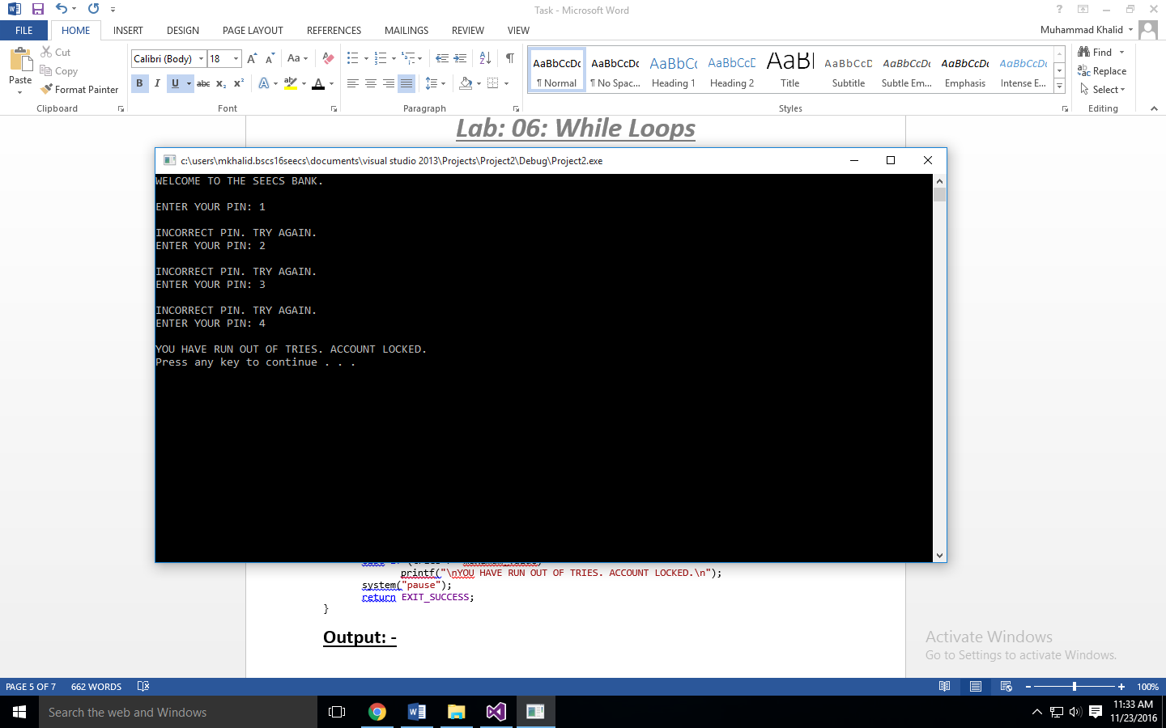

**Task: 6: PIN Lockout: -**

/*Name : Muhammad Rizwan Khalid

class: BSCS-6A

Reg.No: 180459*/

#include <stdio.h>

#include <stdlib.h>

int main()

{

int a, tries = 0;

printf("I have chosen a number between 1 and 10. Try to guess it out.\n");

printf("Your Guess : ");

scanf_s("%d", &a);

tries++;

while (a != 6)

{

printf("This is incorrect. Guess again.\n");

printf("Your Guess : ");

scanf_s("%d", &a);

tries++;

}

printf("That's right! You Guessed it.\n");

printf("It only took you %d tries.\n", tries);

system("pause");

return EXIT_SUCCESS;

}

**Output:**

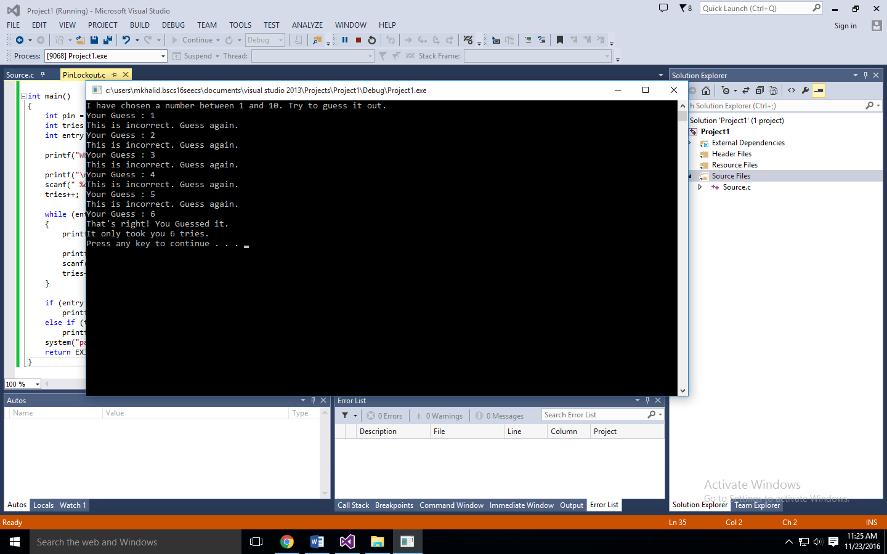

**Task: 07: High-Lo with limited tries: -**

/*Name : Muhammad Rizwan Khalid

Class : BSCS-6A

Reg.No: 180459*/

#define _CRT_SECURE_NO_WARNINGS

#include <stdio.h>

#include <stdlib.h>

#include <time.h>

int main()

{ srand(time(NULL));

time_t;

int a = rand() % 99 + 1;

int tries = 1, guess;

printf("I am thinking of a number between 1-100. You have 7 Guesses.\n");

printf("First Guess : ");

scanf("%d", &guess);

if (guess < a)

printf("Sorry , you are too low.\n");

if (guess > a)

printf("Sorry , that guess is too high\n");

tries++;

while (guess != a && tries <= 7)

{

printf("Guess #%d : ", tries);

scanf("%d", &guess);

if (guess < a)

printf("Sorry , you are too low.\n");

if (guess > a)

printf("Sorry , that guess is too high\n");

tries++;

}

if (guess == a)

printf("You guessed it!\n");

if (tries >= 7)

printf("Thats enough! You have tried for 7 times.\n");

system("pause");

return EXIT_SUCCESS;}

**Output: -**

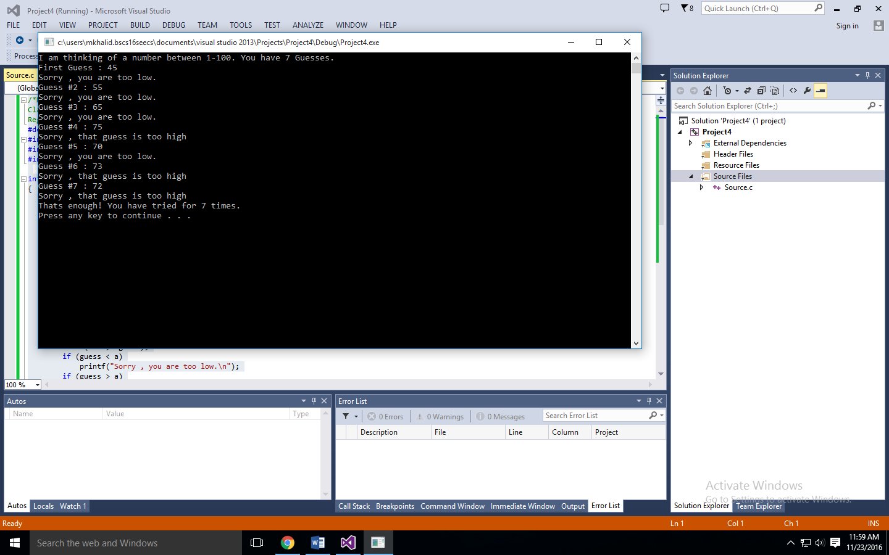

**Task: 08: Add a values in Loop: -**

/*Name : Muhammad Rizwan Khalid

Class : BSCS-6A

Reg.No: 180459*/

#define _CRT_SECURE_NO_WARNINGS

#include <stdio.h>

#include <stdlib.h>

int main()

{

int a, total = 0;

printf("I will add up the numbers you give me.\n");

printf("Number: ");

scanf("%d", &a);

total = total + a;

printf("The total so far is %d.\n", total);

while (a != 0)

{

printf("Number: ");

scanf("%d", &a);

total = total + a;

printf("The total so far is %d.\n", total);

}

system("pause");

return EXIT_SUCCESS;

}

**Output: -**

